卡通人物

The two plates that attached to the arm are made of non-metal material, from the texture of its outside surface, can guess speculate the possibility of carbon fiber or similar material.

Two nylon straps that connect to the two plates are used to fix the exoskeleton to the user’s arm, one of them is located at the upper arm, where the plate will cover the triceps and outer side of the biceps. The other pair is located at the forearm where the plate is beneath and the outer side of the forearm.

The frame of the whole structure is made of metal.

The structure at the hand has the functionality of helping bend the second and third fingers so the user can hold or grasp an item.

Another plate is beneath the hand and can be attached to the thumb with strap, there is a metal V-shape structure that helps fix the position of the thumb

The buttery, microprocessor, motor, gearbox are located at the joint of the structure. The motor can be seen is at the back of the triceps since it is long. And the connection of the upper arm and forearm is under the gear with a bigger radius.

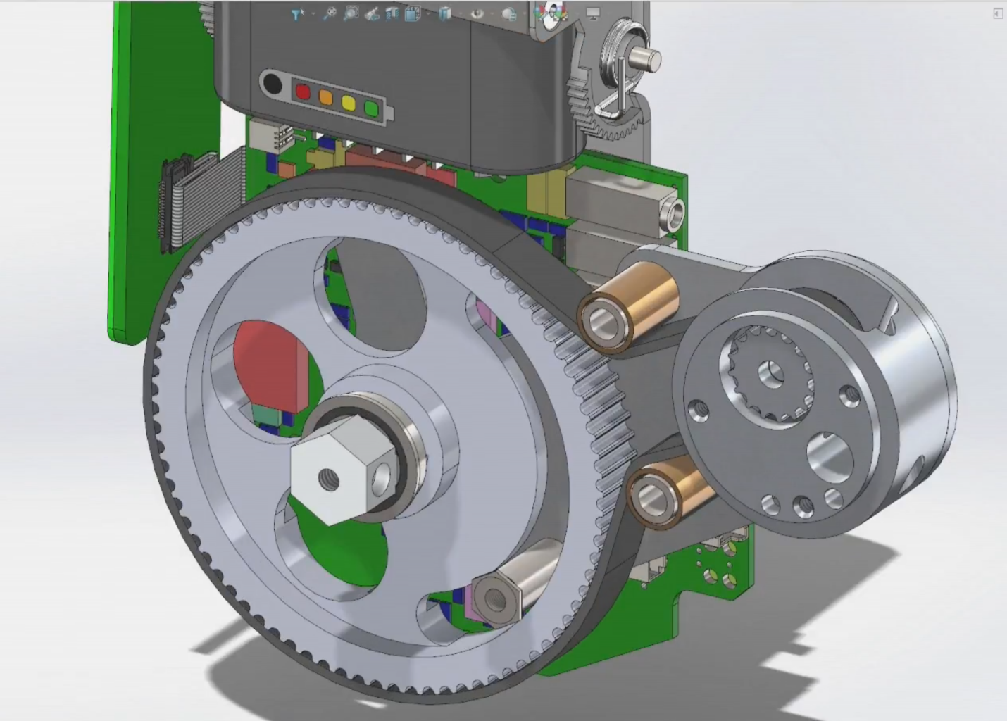

In the above figure is the back side of the gearbox module, the gear and the pinion is connected by strap and there are two plain bearings to restrict the space occupied. The nut that is at the shaft end of the gear is connected to the forearm.

It can be seen that there is a special structure on the gear that can limit the rotation angle of the gear, which is also the forearm structure for safety purpose.

The mechanism of bending fingers are not shown in the video and since it does not require much force, the inner structure may not be complicated.

文本

A metal structure at the wrist that will help fix the whole forearm structure as well as the hand structure. However, with this whole structure the user will not be able to rotate his wrist.

The connection of the wrist structure and the hand plate is adjustable, but the connecting bar and the plate are fixed using bolts which may not be comfortable.

According to the video, the product using millivolt microphone as input for the user to control the movement of his arm.

地上穿着球鞋的一双脚和枪

Website note

**A breakthrough in modern medical robotics**

MyoPro is a powered arm and hand orthosis (brace) designed to help restore function to the wearer's paralyzed or weakened upper extremities, helping individuals perform actions and daily activities that might otherwise be impossible. The MyoPro may also facilitate rehabilitation including muscle re-education and increasing range of motion.

**How does the MyoPro work?**

~~Originally developed at MIT with Harvard Medical School,~~ the MyoPro arm and hand orthosis device works by reading the faint nerve signals (myoelectric signals) from the surface of the skin (fully non-invasive, with no implants) then activating small motors to move the limb as the user intends (no electrical stimulation).

The user is completely controlling their own hand, wrist, elbow, and arm; the robotic arm brace amplifies weak muscle signals to help move the upper limb. It has been called "power steering for your arm."

~~While there are many prosthetic products for those who have lost their arms, hands or legs, and while there are orthotic products to support weak legs, MyoPro is the only wearable robotic device on the market to help restore function for those who still have their arms and hands but are unable to use them.~~

**What is a MyoPro Orthosis?**

MyoPro is a powered brace for your elbows, hands, wrists -- the only such device that can help restore function to an arm and hand weakened or paralyzed by stroke, brachial plexus injury or other neuromuscular disease or injury.

MyoPro may help restore an individual’s ability to perform activities of daily living, including eating a meal, lifting and carrying objects and performing household tasks. Many can return to work, live independently and reduce their overall cost of care.

**How does it work?**

**MyoPal uses the child’s own residual muscle signals**

The EMG signal is a biomedical signal that is a measure of electrical current controlled by nerves and generated in muscles during contraction. In children with arms paralyzed or weakened by injury or disease, the EMG signal may be too weak to allow the arm to function properly. Nonetheless, a weak EMG signal is nearly always present. MyoPal uses patented sensors to read that weak signal from the surface of the skin, amplifies and processes it, then uses it to control small motors in the device. The result is the child’s arm moves in concert with their attempt to make it move. There are no implants and no electrical stimulation.

**MyoPro Orthosis for Neurological Movement Disorders and Injuries**

The MyoPro is indicated for use to support and help move a weak hand and arm, and for functional rehabilitation and improvement. An individual with limited mobility or long-term muscle weakness in the hand and arm due to a neurological movement disorder, injury or other condition may be a candidate for the MyoPro powered arm brace. This portable, lightweight functional orthosis is applicable to a broad range of individuals with muscle weakness, neurological disorders or neuro-muscular damage from conditions ~~including:~~

**Regain Your Independence**

Even after therapy, stroke may leave you with an arm so weak it seems useless or a hand that stays clenched in a fist. The therapist may tell you this is how it will be for the rest of your life. The biggest loss can be your independence. But for many, regaining movement and function in your arm and hand after a stroke is possible.

~~Myomo, a medical robotics company based in Cambridge, MA, has developed the MyoPro. The technology was originally developed at MIT and Harvard Medical School, and hundreds of patients have used it successfully to regain arm use.~~ MyoPro is a unique, patented powered upper limb orthosis designed to restore function to the weakened or paralyzed arms of patients suffering from CVA stroke, brachial plexus injury, traumatic brain or spinal cord injury, ALS or other neuromuscular disease or injury. It works by sensing a patient’s own EMG signals through non-invasive sensors on the arm and driving tiny motors so your arm moves as you want it to -- no implants, no electrical stimulation.

The TSO (Fig. 1a) is actuated with a brushless DC motor, connected to a commercial spur gearbox (26:1) in combination with a custom gear reduction (120:72), is embedded with a torque sensor and an encoder and weighs 1700 g.